Tandez Academy of Martial Arts

Filipino Kali Concepts & Principles

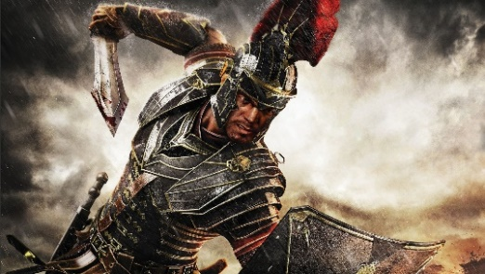

About the Filipino Martial Arts

The backbone of the Filipino empty hand skills is derived from that of the Knife. In a knife fight your entire body is utilized - you can kick with either leg and strike with your free hand. The difference between life or death rests solely on your skill. Little wonder why the Filipino martial arts are so effective.

There is no excuse for taking a man's life, for life is precious. Any man can take a life, but no man can give back a life. Killing is then a matter between a man and his personal conviction and conscience. It is a matter of your own personal belief of right or wrong. It is therefore important to train the mind before training the body.

I once asked a close friend, "What can I do to make this world a better place to live?" His answer, "Develop yourself first." The martial arts have been my way of developing myself physically, mentally and spiritually.

Bruce Lee once said, while philosophizing on martial arts, "Dan, before I studied the art, a punch to me was just like a punch and kick just like a kick. After I learned the art, a punch was no longer a punch, a kick no longer a kick. Now that I've understood the art, a punch is just like a punch, a kick just like a kick.

The height of cultivation is really nothing special. It is merely simplicity, the ability to express the utmost with the minimum.

To all seekers of the way, Knowledge comes from your instructor. Wisdom comes from within.

Guro Dan Inosanto

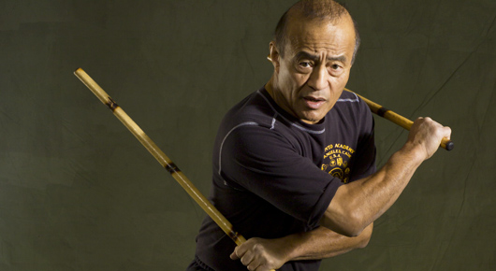
12 Areas of LaCoste Inosanto Kali

1st Area

1. Single Stick
2. Single Sword
3. Single Axe
4. Single Cane

2nd Area

1. Double Stick
2. Double Sword
3. Double Axe
4. Double Cane

3rd Area

1. Stick and Dagger
2. Cane and Dagger
3. Sword and Dagger
4. Sword and Shield
5. Long and Short Stick

4th Area

1. Double Dagger
2. Double Short Sticks

5th Area

1. Single Dagger
2. Single Short Stick

6th Area

1. Palm Stick
2. Double-End Dagger

7th Area Pangamut, Kamot-Kamot or Empty Hands

1. Panantukan (Boxing, to include use of the Elbows)
2. Pananjakman or Sikaran (Kicking, to include use of Knees and Shin)
3. Dumog, Layug, or Buno (Grappling and Locking)
4. Ankab-Pagkusi, or Kina Mutay (Bite and Pinch)
5. Higot-Hubud-Lubud (“Tying-untying, and blending the two”)

8th Area Long Weapons

1. Staff
2. Oar
3. Paddle
4. Spear
5. Spear and Circular Shield
6. Spear and Rectangular Shield
7. Spear and Sword/Stick
8. Spear and Dagger
9. Two Handed Method (Heavy Stick)
10. Two Handed Method (Regular stick)

9th Area Flexible Weapons

1. Sarong (clothing worn in Southern Phillipines and Indonesia)
2. Belt or Sash
3. Whip (Latigo)
4. Rope (Lubid)
5. Chain (Cadena)
6. Scarf/Headband
7. Handkerchief
8. Flail (Olisi Toyok)
9. Tabak Toyok
10. Yo-yo
11. Stingray Tail

10th Area Hand-Thrown weapons, Tapon-Tapon

1. Spear
2. Dagger
3. Wooden Splinter
4. Spikes
5. Coins, Washers
6. Stones, Rocks
7. Sand, Mud, Dirt
8. Pepper, Powder
9. Any object that can be thrown

11th Area Projectile Weapons

1. Bow and Arrow (Pana)
2. Blowgun (Sumpit)
3. Slingshot (Pana Palad)
4. Lantanka (Portable Cannon)

12th Area

1. Mental, Emotional, Spiritual training
2. Healing Arts
3. Health Skills
4. Rhythm and Dance
5. History, Philosophy and Ethics

LaCoste Inosanto Four Count Salutation

1. I come to you with an open heart and an open mind
2. I acknowledge that the hand of friendship is superior to the hand of war.
3. I will take what I learn into my heart and my mind.
4. And may we shed no blood.

LaCoste Inosanto Twelve Count Salutation

1. I stand before the Creator and Mankind on earth.
2. I am striving for the knowledge and wisdom of the third eye, of the five senses and beyond the five senses. 3. I am striving for the love of all mankind and there will be no needless shedding of blood.
4. I bow down to you not in submission, but in respect to you.
5. I extend the hand of friendship, because I prefer it to the hand of war.
6. But if my friendship is rejected, I am trained to be a warrior with wisdom.
7. I stand in symbolism, for I serve only the Creator, my family, and my country.
8. With my mind and heart I cherish the knowledge given to me by my instructor
9. For it is my very life in combat.
10. I am prepared to go against you even though your skill might be greater than mine.
11. Because even if my physical body should fall before you to the earth, I am not worried.
12. For I know that my spirit will arise to the heavens, as it is unconquerable.

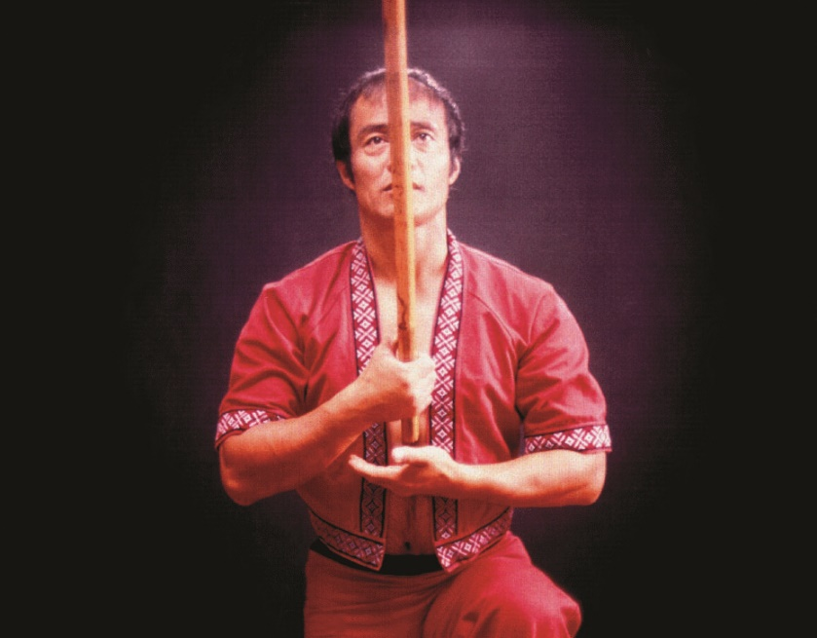
The Symbolism Behind the LaCoste Inosanto Kali Logo

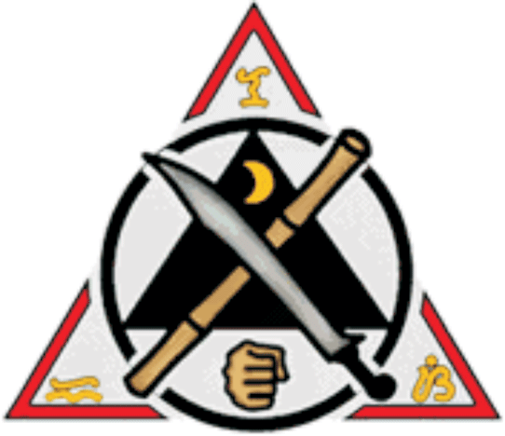

1. The Universal Triangle
2. The Circle represents the Creator - form with continuous motion.
3. The Kali Triangle - love, compassion, humility.
4. The Stick - the core of the Filipino Martial Arts; the first weapon taught, from which to learn all other weapons.
5. The Blade (points upward toward Life) - the blade is taught after the stick.
6. The Fist - represents the Empty Hand Art of the Philippines
7. The Half Moon - symbolizes the half of the Philippines (Southern Philippines) which were never under Spanish rule; also the Moonlight, which was the only time Kali practitioners could safely practice their art during Spanish rule.
8. The Four Parts of the circle represent the Four Saints called upon by Kali practitioners
9. Saint Michael, Saint Gabriel, Saint Uriel and Saint Raphael
10. Ancient "K" for Kali, Kaliradman
11. Ancient "E" for Eskrima, Estocada and Estoke
12. Ancient "S" for Silat

7 Ways to Train LaCoste Inosanto Kali

There are seven ways to train the 12 areas of Inosanto LaCoste Kali:

1. Abecedario – One side continually feeds, the other side defends and counter-attacks. Abecedario has twelve stages.

2. Contra Sumbrada – a counter-for-counter training method. Sumbrada has twelve stages.

3. Mixing Abecedario and Sumbrada

4. Solo Training
5. Hitting Objects
6. Sparring
7. Visualization, meditation

These 12 “areas” are sometimes referred to as “Sub-Systems” due to the fact that each sub-system can be broken down with several individual parts and each have their own specific traits and personality.

At Inosanto Academy they have added Muay Thai to the Sikaran to make it more complete and to adapt to its training methods. Guro Dan Inosanto often uses this system because of its efficient organizational structure.

LaCoste Inosanto Kali Training Methodology

Abecedario Weapons Progression

- Sword & Dagger vs. Sword & Dagger
- Sword vs. Sword & Dagger
- Double Sword vs. Sword & Dagger
- Sword vs. Sword
- Double Sword vs. Double Sword
- Dagger vs. Dagger
- Double Dagger vs. Dagger
- Double Dagger vs. Double Dagger
- Empty Hands vs. Dagger
- Empty Hands vs. Double Dagger
- Empty Hands vs. Empty Hands
- Sarong, Handkerchief, Rope vs. Dagger
- Sarong, Handkerchief, Rope vs. Double Dagger
- Sword vs. Staff
- Sword & Dagger vs. Staff
- Double Sword vs. Staff
- Staff vs. Staff
- Sword vs. Double Sword
- Spear vs. Staff
- Staff vs. Spear
- Spear vs. Spear

12 Areas of Abecedario
(Stages 1-7 are done in De Fondo)

1. Block and Hit
2. Block and 2 Hits
3. Block and 3 Hits
4. Receive 2 Hits
5. Receive 3 Hits
6. Receive Fakes to Positive
7. Mixed
  - Using Different Weapons
  - Receiving Different Weapons
  - Using Different:
      - Chokes
      - Disarms
      - Locks
      - Sweeps
      - Takedowns
      - Throws
      - Trips
8. Receive while Retreating
9. Receive while Moving Right or Left
10. Receive While Circling Right or Left
11. Receive Low to High or High to Low
12. Receive on Different Terrains, Environments and/or Situations

12 Stages of Contra Sumbrada

Stage 1
1 Block and 1 Hit

Stage 2
Hitting Block (Arm or Body) & 1 Hit

Stage 3
1 Block and 2-3 Hits

Stage 4
1 Block & 2-3 Hits
Negative to Positive Hit
Fake to a True Strike
Use of Progressive Indirect Attack & Deception

Stage 5
A. Punyo & Punta Sumbrada
a. Punyo Sumbrada
b. Punta Sumbrada
c. Punta Sumbrada with Dungab (punch)

Stage 6
Punyo & Punta Sumbrada
Higot Hubud-Lubud to Punyo Sumbrada
Higot Ug Hampak (Tie & Hit)
Hubud Ug Hampak (Untie & Hit)
Lubud Ug Hampak (Blend & Hit)

Stage 7
Entrada Y Retirada: Long Range to Middle Range to Close Quarter Range
Breaking In and Breaking Out

Stage 8
Add Elements:
- Joint Breaks
- Disarms
- Finger Strikes
- Forearm Strikes
- Hand Strikes
- Kicks
- Knees
- Locks
- Punches
- Strangles
- Other Strikes
- Throws

Stage 9
Block & Hit Limbs

Stage 10
Using Different Weapons:
- Blade & Shield
- Blades
- Club
- Spears
- Staff
- Tjibang Sticks

Stage 11
- Add Different Environments
- Counter with Dumog
- With or Without Weapons

Stage 12
Sparring
- Non-Contact Distance Sparring
- Light-Contact
- Middle Range & Close Quarter
- Long Range to Limbs and Hands Only
3. Medium Contact to Limbs, Body and Head – Body Armor and Headgear is Mandatory
4. Medium to Heavy Contact – Body Armor and Headgear is Mandatory
5. Medium to Heavy Contact including:

- Kicks
- Punches
- Strikes
- Chokes
- Arm Locks
- Throws
- Sweeps
- Trips
- Takedowns
- Grappling

Kali (Origin of the Word)

Kamot Lihok
KA LI
Kamot Lihok
Hand Motion
Body Motion

According to Grandmaster Floro Villabrille - Kali is a weapons and empty hand system of combat

Arnis De Mano Eskrima
Three Areas of Arnis 1. Single Stick
1. Single Baston 2. Double Stick
2. Double Baston 3. Stick and Dagger
3. Baston and Daga 4. Dagger
5. Empty Hands
6. Staff
7. Flexible Weapons

Villabrille-Largusa System of Kali

(Components)
1. Eskrima
2. Arnis
3. Sikaran
4. Kuntaw
5. Silat
6. Kaliradman
7. Kalirogan
8. Pagkalikali

Kali - Crew of the Ships of Magellan

1. 30 Italians
2. 19 French
3. A few English
4. A few Flemish
5. A few Sicilians
6. A few from Cortiz
7. A few Malays
8. A few Blacks
9. A few Maderanians
10. A few from the Azores & Cotorzans
11. And 1 Filipino – Enrique

Kali – Eskrima

To better understand the Martial Arts
You must Understand the History

To Understand the history
You must Understand the Culture

To Understand the Culture
You must Understand the Philosophy and the Philosophers
And what they were trying to express to the people of that time period.

Kali LaCoste - Systems of Progression

Daan and Lihok System

A system of paths and routes of motion

A. Weapon Routes in Motion
B. Footwork Routes in Motion
C. Body Routes in Motion
D. Hand Routes in Motion
E. Elbow Routes in Motion
F. Knee Routes in Motion
G. Kicking Routes in Motion

Kali Defensive Systems

Stick or Weapons:

1. Stick
2. Sword
3. Axe
4. Staff
5. Spear
6. Flexible Weapons
7. Dagger
8. Palm Stick

- Inside Defensive System (Parry-Cover-Block)
- Outside Defensive System
- Wing Defensive System
- Roof Defensive System
- Shield Defensive System
- Gunting Defensive System
- Umbrella Defensive System
- Largo Mano – Meet the Force (La Contra)
- Largo Mano – Follow the Force (Seguidas)
- Largo Mano – Backhand (Ordabis)
- Largo Mano – Forehand

Ranges of Combat

- Largo Mano (Long Range): You can only hit the weapon hand, but not the head or body
- Sumbrada (Middle Range): You can hit the head and body – the Alive Hand is engaged
- Hubud-Lubud (Close Range): You can hit with the Punyo – also headbutt, elbows, & knees

Fundamental Kali Principles

- No Passive Blocks: No true blocks in Kali - Blocks represent hits to the hands/arms
- Deflection Force: Attack the weapon with sufficient energy and force to re-direct it
- Perpetual Motion: Always stay in constant movement; never remain static or fixed
- Flow: All motions are one continuous flow from block to hit
- Theory of Zero Pressure: Avoid 100 degrees of pressure by zoning away using triangle footwork

Entry Methods of Kali

- De-Fanging the Snake: Destroy the enemy’s weapon hand/s to disarm him and incapacitate him.

- Angulation – Use body angulation and footwork to avoid the attack, then hit any open targets.

Sinawali 6 Count Families

- I-I-I Inward, Inward, Inward 64
- I-B-B Inward, Backhand, Backhand 64
- I-B-I Inward, Backhand, Inward 64
- B-B-B Backhand, Backhand, Backhand 64
- I-I-B Inward, Backhand, Backhand 64
- B-I-I Backhand, Inward, Inward 64
- B-B-1 Backhand, Backhand, Inward 64
- B-I-B Backhand, Inward, Backhand 64
Total Variables 512

Sinawali: Key to Variable Heights

- H-H-H
- H-L-H
- L-L-L
- L-H-L
- L-L-H
- H-H-L
- L-H-H
- H-L-L

Sinawali 6 Count Patterns

- H-H-H H-H-H
- H-H-L H-H-L
- H-L-L H-L-L
- H-L-H H-L-H
- L-H-L L-H-L
- L-L-L L-L-L
- L-L-H L-L-H
- L-H-H L-H-H
Inosanto Kali Numbering Systems

- LaCoste #1-12
- LaCoste #1-17
- LaCoste #1-25
- Illustrisimo System #1-12 (Regino Illustrisimo)
- Illustrisimo System #1-8 (Regino Illustrisimo)
- Kalis Illustrisimo #1-12 (Antonio Illustrisimo)
- Lameco Eskrima #1-12 (Baston)
- Balintawak Eskrima, #1-12
- Pekiti Tersia A & B
- Villabrille #1-12

Kali Knife System

Numbering System

- LaCoste Dungab #1 - 17
- LaCoste Pakal #1 - 17
- Lameco Escrima #1 – 17

Footwork

- Forward Triangle
- Reverse Triangle
- Lateral Step
- Push Shuffle
  - Advance
  - Retreat
- Ambak Paewas
  - 180 Straight Line
  - Step-Swing Line

Cut Time Table

- Flexor Muscles
- Extensor Muscles

Knife Tapping

- Single Tap
- Triple Tap

Escala

- Slash
- Thrust
- Tear (Rip)
- Punyo (Butt)

Passing (Palusot)

- Outside Ride (Palusot)
- Stop (Segung)
- Ambak
- Waslik

Abecedario

- Dungab vs. Dungab
- Dungab vs. Pakal
- Pakal vs. Pakal
- Pakal vs. Dungab
- Double-End Dagger vs. Single Dagger
- Single Dagger vs. Double-End Dagger
- Double-End Dagger vs. Double-End Dagger

Pathways

- Vertical lines
- Horizontal lines
- Diagonal up and down
- Circular lines
- Thrusting lines

Targets

- Bleeders
- Immobilizers
- Sudden Death

Panantukan (Filipino Boxing) Concepts

Creating Openings

- Stop-Hit - Intercepting strike (Jeet Kune)
- Atapi/Tapi - Slapping hand trap and strike (Pak Sao Da)
- Panastas – Sliding Leverage Hit (Noy Bil Jee)
- Forearm Drop and Hit – Low block against a low line strike (Low Cover)
- False Attack – P.I.A - Fake a strike then take advantage of an opening or over-commitment
- Engano: Change of attack lines - Progressive Indirect Attack
- Projectiles - Throw objects at or above his head to create an opening
- Spitting - Spit at your opponent’s face, to create an opening

Identifying Openings

- No Movement – Opponent is Static
- Repeating Patterns
- Dictating Patterns
- Poor Stance
- Narrow Position – “Tightrope” – easily unbalanced from a lateral attack
- Staggered Wide Stance: open for attack – lead knee/shin, groin, thigh; can easily be unbalanced because feet are too wide apart; cannot move fast
- Poor Footwork
- Crossing Feet – opponent crosses foot behind foot, instead of slide-and-step
- Opponent Focuses on One Area
- Focus on High Line/Punches: Attack the Low Line
- Focus on Low Line/Kicks: Attack the High Line

Panantukan Strategy & Tactics

- Destroy/disrupt his Base and Balance before you hit
- Use a variety of tools in different ways – Knowledge is Power
- Use Nerve and Limb Destructions - DeFang the Snake
- Use Angulation and Switching Leads – avoid meeting force with force
- Use Sectoring aka the Chess Game: Always stay 10 steps ahead of your enemy

Kali Environmental Positions

1. Standing Position - Tindog
2. Squatting Position - Katin-Katin
3. Kneeling Position – Luhod
4. Sitting Position - Lingkud
5. Lying Position – Higda/Higa

Kali Dumog – Areas of Kunsi

1. Face Down (Upper Section)
2. Face Up (Upper Section)
3. Right Side Up
4. Left Side Up
5. Theory of Clock Approach
6. Entries
A. Gunting (Horizontal)
B. Gunting (Vertical)

Carrenza (Shadowboxing w/ Weapons)

Before you begin Carrenza, you must know the characteristics of the weapon you are using and the specific attributes that it develops.

Stroking Patterns

- X = Diagonal Patterns – Downward Diagonal Slashing or Upward Diagonal Slashing
- + = Crossing Patterns – Vertical and Horizontal Slashing or Smashing
- 8 = Figure 8 Patterns
- 0 = Circular Patterns – Redondos and any round patterns
- @ = Thrusting Patterns

Tools

- Witik – Retracting or snapping back motions
- Labtik – Follow through motions
- Abanico – Fanning motions
- Redondo – Tight circular motions
- Florette – Flowery or circular motions
- Sungkite – Thrusting motions
- Bacalau – Wide motion that involve ducking your head and dropping your body weight

